
Task 1
Basic Network Sniffer
Student Name | Amir Khan
Student ID | CA/DF1/149163
Internship Track | Cyber security internship
Submission Date | 07/07/2026
Week /Task | Task 1

1. Task Overview
In this task, I will build a Python-based network sniffer , a program that captures live network traffic (data packets) passing through the system. The tool will analyze each captured packet to understand its structure, extract useful information like source/destnation IP addresses, protocol type, and payload data. This is a foundational cyberscurity skill used in network monitoring, traffic analysis, and intrusion detection.

2. Learning Objectives
By the end of this task, the student will be able to:
- Understand how data packets travel across a network
- Learn the basics of networking protocols (TCP, UDP, ICMP, etc.)
- Use Python libraries (scapy or socket) to capture live network traffic
- Parse and analyze packet structure (headers, payload)
- Extract and display key packet details: source IP, destination IP, protocol, and payload

3. Lab Environment and Prerequisites
Tools needed:
Tool | Purpose
Python 3.x | Programming language
Scapy library | Packet capturing and analysis
Admin/root access | Required to capture live network packets

Steps Followed:
Step 1: Install Scapy
pip install scapy
Step 2: Install Npcap
Since Scapy needs a packet-capture driver on Windows, Npcap was downloaded and installed from npcap.com, with the "WinPcap API-compatible Mode" option enabled during installation.
Step 3: Write the Sniffer Script
A Python script was written using Scapy's sniff() function, which captures packets and passes each one to a custom function (process_packet) for analysis.
Step 4: Extract Packet Information
For every captured packet, the script checks if it contains an IP layer, then extracts:
- Source IP and Destination IP
- Protocol type (TCP / UDP / ICMP)
- Port numbers (for TCP/UDP)
- Payload data (if present)
Step 5: Run the Script (Administrator Mode)
The script was executed using Command Prompt opened as Administrator:
python network_sniffer_fixed.py
Step 6: Generate Test Traffic
While the sniffer was running, a browser was opened to visit websites, generating real network traffic for the sniffer to capture and display.
Basic Network Sniffer:
A simple Python tool to capture live network packets, analyze their
structure, and display useful information such as source/destination
IPs, protocol type, ports, and payload data.

from scapy.all import sniff, IP, TCP, UDP, ICMP

# Counter to keep track of number of packets captured
packet_count = 0

def process_packet(packet):
"""
This function is called automatically by scapy for every
packet that is captured. It extracts and displays key details.
"""
global packet_count
packet_count += 1

print(f"\n[Packet #{packet_count}]")
print("-" * 60)

if packet.haslayer(IP):
src_ip = packet[IP].src
dst_ip = packet[IP].dst
protocol_ip = packet[IP].proto
ttl = packet[IP].ttl

print(f"Source IP : {src_ip}")
print(f"Destination IP : {dst_ip}")
print(f"Protocol IP : {protocol_ip}")
print(f"TTL : {ttl}")

if packet.haslayer(TCP):
tcp_layer = packet[TCP]
print(f"Protocol : TCP")
print(f"Source Port : {tcp_layer.sport}")
print(f"Destination Port: {tcp_layer.dport}")
print(f"Flags : {tcp_layer.flags}")

elif packet.haslayer(UDP):
udp_layer = packet[UDP]
print(f"Protocol : UDP")
print(f"Source Port : {udp_layer.sport}")
print(f"Destination Port: {udp_layer.dport}")

elif packet.haslayer(ICMP):
print(f"Protocol : ICMP (e.g., ping request/reply)")

else:
print(f"Protocol : Other (IP protocol number: {protocol_ip})")

if packet.haslayer("Raw"):
payload = packet["Raw"].load
print(f"Payload : {payload[:100]}") # only first 100 bytes for readability

print("-" * 50)

else:
# Non-IP packets (e.g., ARP) will land here
print("Non-IP packet captured.")
print(packet.summary())
print("-" * 50)

print("Sniffing started... Press Ctrl+C to stop.\n")

try:
sniff(prn=process_packet, count=20)
except KeyboardInterrupt:
print("\nSniffing stopped by user.")
except PermissionError:
print("\n[ERROR] Permission denied. Run as Administrator (Windows) or with sudo (Linux).")

print(f"\nTotal packets captured: {packet_count}")
print("Sniffing session ended.")

Out Put:
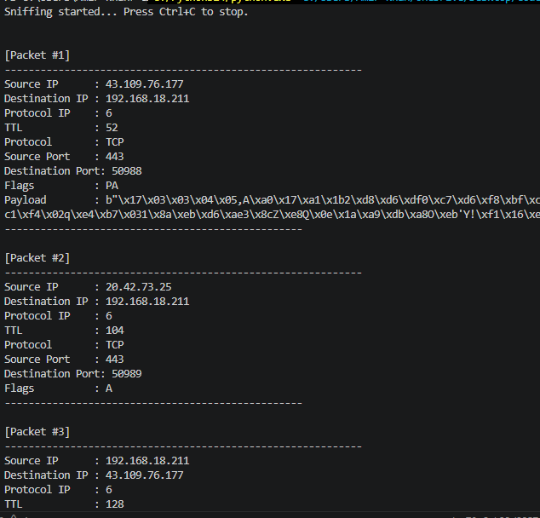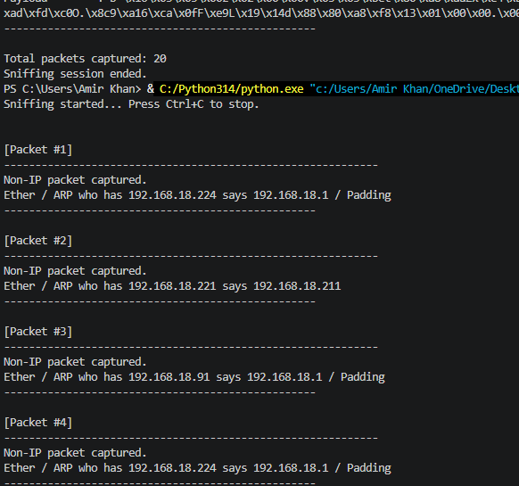

Conclusion
The sniffer successfully captured live packets and displayed their source/destination IPs, protocols, ports, and payload data in real time. This task provided hands-on understanding of how network traffic can be intercepted and analyzed at the packet level — a core skill used in network monitoring and cybersecurity analysis.

